Friday, 06/09/2019

**PRESS RELEASE**

**10th Balkans Beyond Borders Short Film Festival**

**SPECIAL SCREENING: BBB FOCUS SCOTLAND**

The **10th Balkans Beyond Borders Short Film Festival "e-motions"** will feature a special screening of Scottish short Films under the title BBB FOCUS: SCOTLAND. The screening is in collaboration with the Edinburgh Short Film Festival and it will take place on Saturday, the 19th of October at 21:30 to 23:00 aiming at discovering Scottish stories and culture through specially selected short films by young filmmakers. The screening will follow live music with the Celtic band Noriana.

The Edinburgh Short Film Festival aims to provide a platform where high quality short films made by talented local film-makers can be screened alongside the best in contemporary UK and International short films.

Balkans Beyond Borders Short Film Festival every year alongside to the Competition Programme with Balkan shorts focuses on a specific country/state beyond the Balkans, in order to shed light to young film makers and enhance multiculturalism. After a long journey from Germany to Japan and from Estonia to Austria, this year our FOCUS is on SCOTLAND.

The programme will consist of the films below:

THE WIDER SUN, Sophia Carr-Gomm 15 Mins

SLINGSHOT, Robin Haig 15 Mins

HAUD CLOSE TAE ME, Eve McConnachie 5 mins

FREE PERIOD, Alison Piper 6 mins

SALT & SAUCE, Alia Ghafar 11 mins

NOT REQUIRED BACK, Peter Marsden 7 mins

OOR WALLY, Martin Lennon 12 mins

LOVE CAKE, Eleanor Yule 10 mins

About Balkans Beyond Borders

Balkans Beyond Borders (BBB) is a non-for-profit organization, with its head office in Athens, that from 2010 seeks to promote youth mobility and youth cooperation in the Balkans through “dialogue”, “interaction” and “innovative thinking”. Investing in the region’s young people, and through its flagship activity the moving BBB Short Film Festival, BBB aims to create an Inter- Balkan network able to promote efficiently the work of young artists of the region and beyond, in order to familiarize its audience to the Balkan culture and its diversity. Balkans Beyond Borders has been awarded twice from the EU for its contribution to civil society, because through its actions it succeeds at raising awareness for important issues

In cooperation with



CONSORTIUM

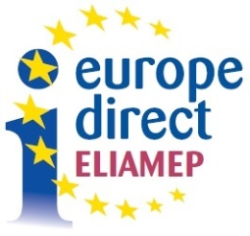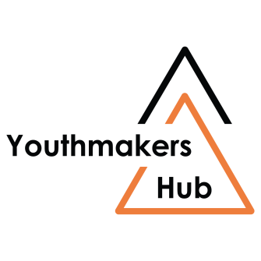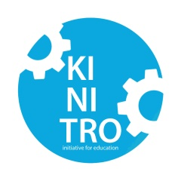 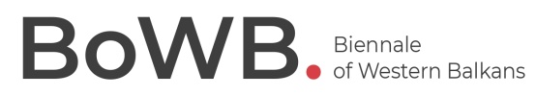

«The tribute «YOUTH AND LABOR / WOMEN AND LABOR» is co-funded by:

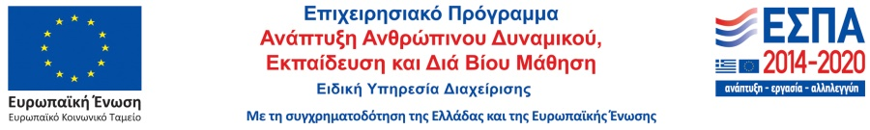

With the support

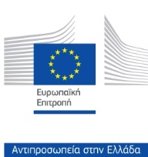 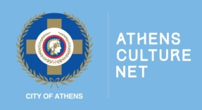

Communication Support



